MINI-PROJECT

RTL CODE:
`timescale 1ns / 1ps
module uart_top #(
parameter CLKS_PER_BIT = 10417,
parameter DB_CYCLES = 1_000_000
)(
input clk,
input [15:0] sw,
input [3:0] btn,
input UART_rxd,
output UART_txd,
output [15:0] led
);
localparam IDLE = 2'd0, START = 2'd1, DATA = 2'd2, STOP = 2'd3;

reg rst_s1 = 0, rst = 0;
reg b1 = 0, b2 = 0, b_stable = 0, send_pulse = 0;
reg [20:0] db_cnt = 0;
always @(posedge clk) begin
rst_s1 <= btn[3]; rst <= rst_s1;
b1 <= btn[0]; b2 <= b1; send_pulse <= 1'b0;
if (b2 == b_stable) db_cnt <= 0;
else if (db_cnt == DB_CYCLES-1) begin
b_stable <= b2; db_cnt <= 0;
if (b2) send_pulse <= 1'b1;
end else db_cnt <= db_cnt + 1'b1;
end
reg [1:0] tx_state = IDLE;
reg [15:0] tx_cnt = 0;
reg [2:0] tx_idx = 0;
reg [7:0] tx_sh = 0;
reg tx = 1'b1;
wire tx_busy = (tx_state != IDLE);

always @(posedge clk) begin
if (rst) begin
tx_state <= IDLE; tx <= 1'b1; tx_cnt <= 0; tx_idx <= 0;
end else case (tx_state)
IDLE: begin
tx <= 1'b1; tx_cnt <= 0; tx_idx <= 0;
if (send_pulse) begin tx_sh <= sw[7:0]; tx_state <= START; end
end
START: begin
tx <= 1'b0;
if (tx_cnt == CLKS_PER_BIT-1) begin tx_cnt <= 0; tx_state <= DATA; end
else tx_cnt <= tx_cnt + 1'b1;
end
DATA: begin
tx <= tx_sh[tx_idx];
if (tx_cnt == CLKS_PER_BIT-1) begin
tx_cnt <= 0;
if (tx_idx == 3'd7) begin tx_idx <= 0; tx_state <= STOP; end
else tx_idx <= tx_idx + 1'b1;
end else tx_cnt <= tx_cnt + 1'b1;
end
STOP: begin
tx <= 1'b1;
if (tx_cnt == CLKS_PER_BIT-1) begin tx_cnt <= 0; tx_state <= IDLE; end
else tx_cnt <= tx_cnt + 1'b1;
end
endcase
end

wire rx_line = sw[15] ? tx : UART_rxd;
reg rx_s1 = 1, rx_s2 = 1;
reg [1:0] rx_state = IDLE;
reg [15:0] rx_cnt = 0;
reg [2:0] rx_idx = 0;
reg [7:0] rx_sh = 0;
reg [7:0] rx_data = 0;
reg rx_toggle = 0, frame_err = 0;

always @(posedge clk) begin
rx_s1 <= rx_line; rx_s2 <= rx_s1;
if (rst) begin
rx_state <= IDLE; rx_cnt <= 0; rx_idx <= 0;
rx_data <= 0; rx_toggle <= 0; frame_err <= 0;
end else case (rx_state)
IDLE: begin
rx_cnt <= 0; rx_idx <= 0;
if (rx_s2 == 1'b0) rx_state <= START;
end
START: begin
if (rx_cnt == (CLKS_PER_BIT-1)/2) begin
rx_cnt <= 0;
rx_state <= (rx_s2 == 1'b0) ? DATA : IDLE;
end else rx_cnt <= rx_cnt + 1'b1;
end
DATA: begin
if (rx_cnt == CLKS_PER_BIT-1) begin
rx_cnt <= 0;
rx_sh[rx_idx] <= rx_s2;
if (rx_idx == 3'd7) begin rx_idx <= 0; rx_state <= STOP; end
else rx_idx <= rx_idx + 1'b1;
end else rx_cnt <= rx_cnt + 1'b1;
end
STOP: begin
if (rx_cnt == CLKS_PER_BIT-1) begin
rx_cnt <= 0; rx_state <= IDLE;
frame_err <= ~rx_s2;
if (rx_s2) begin rx_data <= rx_sh; rx_toggle <= ~rx_toggle; end
end else rx_cnt <= rx_cnt + 1'b1;
end
endcase
end
assign UART_txd = tx;
assign led = {5'b00000, rx_toggle, frame_err, tx_busy, rx_data};
endmodule

TESTBENCH:

`timescale 1ns / 1ps
module tb_uart;
localparam CPB = 16; // small divider for simulation
localparam BIT_T = CPB * 10; // bit time in ns (10 ns clock)

reg clk = 0;
reg [15:0] sw = 0;
reg [3:0] btn = 0;
reg rxd = 1;
wire txd;
wire [15:0] led;

uart_top #(.CLKS_PER_BIT(CPB), .DB_CYCLES(4)) dut (
.clk(clk), .sw(sw), .btn(btn),
.UART_rxd(rxd), .UART_txd(txd), .led(led));

always #5 clk = ~clk;

integer errors = 0;

task press_send;
begin
btn[0] = 1; repeat (20) @(posedge clk);
btn[0] = 0; repeat (20) @(posedge clk);
end
endtask

// act like the PC: drive a byte serially into UART_rxd
task send_serial(input [7:0] b);
integer i;
begin
rxd = 0; #(BIT_T);
for (i = 0; i < 8; i = i + 1) begin rxd = b[i]; #(BIT_T); end
rxd = 1; #(BIT_T);
end
endtask

task check_led(input [7:0] exp);
begin
if (led[7:0] !== exp) begin
$display("FAIL: expected %h, got %h", exp, led[7:0]);
errors = errors + 1;
end else
$display("PASS: received %h", led[7:0]);
end
endtask

// independent monitor on the TX line: decodes what the DUT transmits
reg [7:0] mon;
integer k;
always @(negedge txd) begin
#(BIT_T/2); // middle of start bit
for (k = 0; k < 8; k = k + 1) begin #(BIT_T); mon[k] = txd; end
#(BIT_T); // middle of stop bit
if (txd !== 1'b1) begin $display("FAIL: stop bit not 1"); errors = errors + 1; end
$display("[%0t ns] TX monitor decoded %h", $time, mon);
end

initial begin
// reset
btn[3] = 1; repeat (10) @(posedge clk);
btn[3] = 0; repeat (10) @(posedge clk);

// Test 1: internal loopback (sw15 = 1)
sw[15] = 1;
sw[7:0] = 8'hA5; press_send; #(BIT_T*12); check_led(8'hA5);
sw[7:0] = 8'h3C; press_send; #(BIT_T*12); check_led(8'h3C);
sw[7:0] = 8'h00; press_send; #(BIT_T*12); check_led(8'h00);
sw[7:0] = 8'hFF; press_send; #(BIT_T*12); check_led(8'hFF);

// Test 2: external pin / PC mode (sw15 = 0)
sw[15] = 0;
send_serial(8'h41); #(BIT_T*2); check_led(8'h41); // 'A'
send_serial(8'h7E); #(BIT_T*2); check_led(8'h7E);

if (errors == 0) $display("ALL TESTS PASSED");
else $display("%0d TEST(S) FAILED", errors);
$finish;
end
endmodule

CONSTRAINT FILE:
## Boolean board (Spartan-7 XC7S50) constraints for uart_top

## 100 MHz clock
set_property -dict {PACKAGE_PIN F14 IOSTANDARD LVCMOS33} [get_ports {clk}]
create_clock -period 10.000 -name sys_clk [get_ports {clk}]

## Bank 0 voltage
set_property CFGBVS VCCO [current_design]
set_property CONFIG_VOLTAGE 3.3 [current_design]

## Slide switches
set_property -dict {PACKAGE_PIN V2 IOSTANDARD LVCMOS33} [get_ports {sw[0]}]
set_property -dict {PACKAGE_PIN U2 IOSTANDARD LVCMOS33} [get_ports {sw[1]}]
set_property -dict {PACKAGE_PIN U1 IOSTANDARD LVCMOS33} [get_ports {sw[2]}]
set_property -dict {PACKAGE_PIN T2 IOSTANDARD LVCMOS33} [get_ports {sw[3]}]
set_property -dict {PACKAGE_PIN T1 IOSTANDARD LVCMOS33} [get_ports {sw[4]}]
set_property -dict {PACKAGE_PIN R2 IOSTANDARD LVCMOS33} [get_ports {sw[5]}]
set_property -dict {PACKAGE_PIN R1 IOSTANDARD LVCMOS33} [get_ports {sw[6]}]
set_property -dict {PACKAGE_PIN P2 IOSTANDARD LVCMOS33} [get_ports {sw[7]}]
set_property -dict {PACKAGE_PIN P1 IOSTANDARD LVCMOS33} [get_ports {sw[8]}]
set_property -dict {PACKAGE_PIN N2 IOSTANDARD LVCMOS33} [get_ports {sw[9]}]
set_property -dict {PACKAGE_PIN N1 IOSTANDARD LVCMOS33} [get_ports {sw[10]}]
set_property -dict {PACKAGE_PIN M2 IOSTANDARD LVCMOS33} [get_ports {sw[11]}]
set_property -dict {PACKAGE_PIN M1 IOSTANDARD LVCMOS33} [get_ports {sw[12]}]
set_property -dict {PACKAGE_PIN L1 IOSTANDARD LVCMOS33} [get_ports {sw[13]}]
set_property -dict {PACKAGE_PIN K2 IOSTANDARD LVCMOS33} [get_ports {sw[14]}]
set_property -dict {PACKAGE_PIN K1 IOSTANDARD LVCMOS33} [get_ports {sw[15]}]

## LEDs
set_property -dict {PACKAGE_PIN G1 IOSTANDARD LVCMOS33} [get_ports {led[0]}]
set_property -dict {PACKAGE_PIN G2 IOSTANDARD LVCMOS33} [get_ports {led[1]}]
set_property -dict {PACKAGE_PIN F1 IOSTANDARD LVCMOS33} [get_ports {led[2]}]
set_property -dict {PACKAGE_PIN F2 IOSTANDARD LVCMOS33} [get_ports {led[3]}]
set_property -dict {PACKAGE_PIN E1 IOSTANDARD LVCMOS33} [get_ports {led[4]}]
set_property -dict {PACKAGE_PIN E2 IOSTANDARD LVCMOS33} [get_ports {led[5]}]
set_property -dict {PACKAGE_PIN E3 IOSTANDARD LVCMOS33} [get_ports {led[6]}]
set_property -dict {PACKAGE_PIN E5 IOSTANDARD LVCMOS33} [get_ports {led[7]}]
set_property -dict {PACKAGE_PIN E6 IOSTANDARD LVCMOS33} [get_ports {led[8]}]
set_property -dict {PACKAGE_PIN C3 IOSTANDARD LVCMOS33} [get_ports {led[9]}]
set_property -dict {PACKAGE_PIN B2 IOSTANDARD LVCMOS33} [get_ports {led[10]}]
set_property -dict {PACKAGE_PIN A2 IOSTANDARD LVCMOS33} [get_ports {led[11]}]
set_property -dict {PACKAGE_PIN B3 IOSTANDARD LVCMOS33} [get_ports {led[12]}]
set_property -dict {PACKAGE_PIN A3 IOSTANDARD LVCMOS33} [get_ports {led[13]}]
set_property -dict {PACKAGE_PIN B4 IOSTANDARD LVCMOS33} [get_ports {led[14]}]
set_property -dict {PACKAGE_PIN A4 IOSTANDARD LVCMOS33} [get_ports {led[15]}]

## Push buttons
set_property -dict {PACKAGE_PIN J2 IOSTANDARD LVCMOS33} [get_ports {btn[0]}]
set_property -dict {PACKAGE_PIN J5 IOSTANDARD LVCMOS33} [get_ports {btn[1]}]
set_property -dict {PACKAGE_PIN H2 IOSTANDARD LVCMOS33} [get_ports {btn[2]}]
set_property -dict {PACKAGE_PIN J1 IOSTANDARD LVCMOS33} [get_ports {btn[3]}]

## UART (USB "PROG UART" port)
set_property -dict {PACKAGE_PIN V12 IOSTANDARD LVCMOS33} [get_ports {UART_rxd}]
set_property -dict {PACKAGE_PIN U11 IOSTANDARD LVCMOS33} [get_ports {UART_txd}]
SIMULATION WAVEFORM:
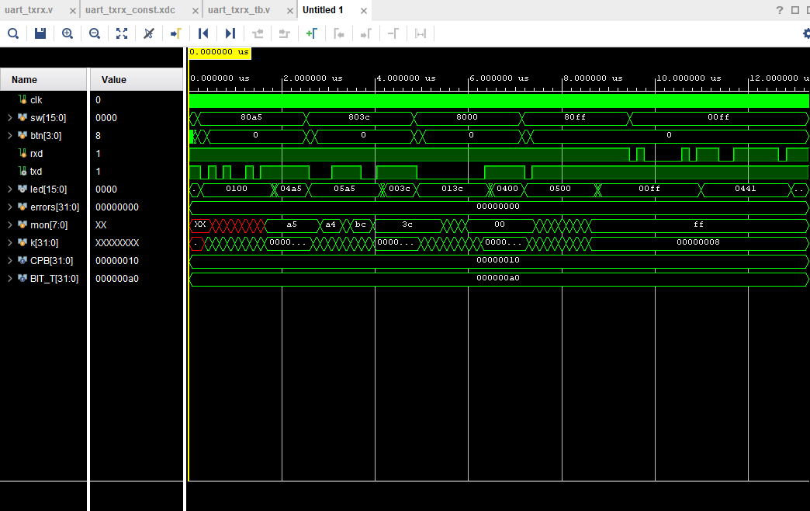

SCHEMATIC:
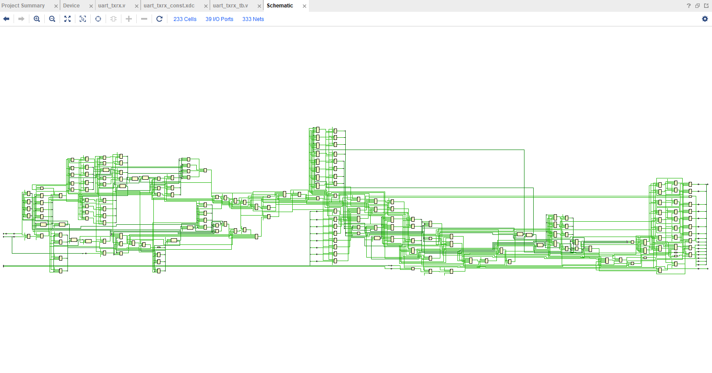

IMPLEMENTED DESGIN:

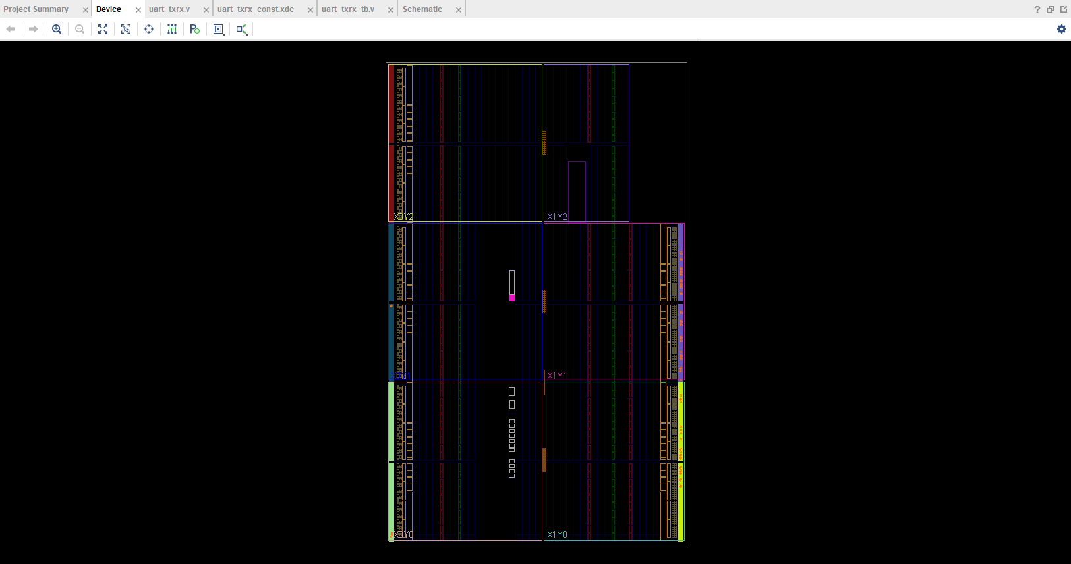

OUTPUT ON TERMINAL:
